Swift Basics 3 – Assignments

1. **Create a function to add two integers and returns an integer value ?**

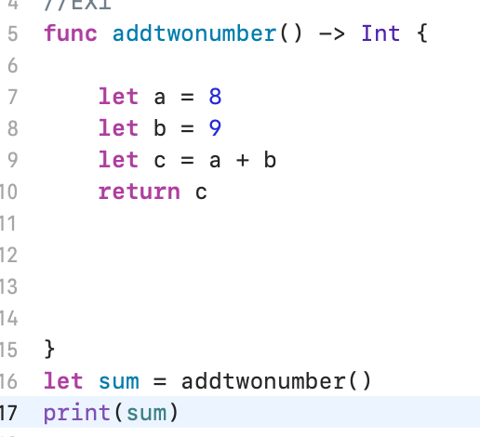

**2. What Causes an Error in This Piece of Code? How Could You Fix It?  
  
let** n1: Int = 1

**let** n2: Float = 2.0

**let** n3: Double = 3.34

**var** result = n1 + n2 + n3

**sol/**

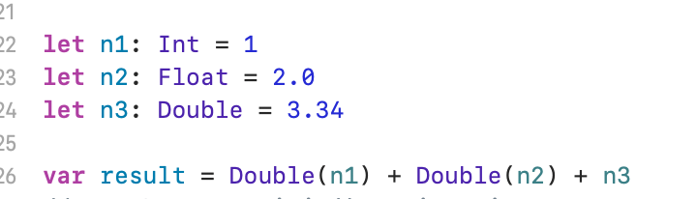

1. **What Does init() Do in Swift?**

// Initialization means an instance (of a class, structure,) for use.

1. **What Are Protocols in Swift? Give an Example**

// protocol is list of methods and properties that have related functionality

**5.What Is the Double Question Mark Operator? Means nil**

/it is an operator that takes two values and returns the right-hand value if the left-hand value is nil, else returns its left-hand value

**6.What Is the Guard Statement?**

. The guard statement is similar to the if statement with one major difference. The if statement runs when a certain condition is met. However, the guard statement runs when a certain condition is not met.7.What Are the Three Primary Collection Types in Swift?

**8.What’s the Difference Between Structures and Classes?**

**Structure: value type, does not support an inheritance..**

**Class: reference type, Classes support an inheritance..**

**9.What is Optional Chaining?**

**Optional chaining means we can call a property of nothing like could be nil. The app wont crash, and will return nil.**

**10.What Is Optional Binding?**

**We will have one value or more (could be nil or other value)**

**11.****What Is an In-Out Parameter in Swift? Give an example?**

**In- Out parameter in swift has a value that’s passed in to the function.**

**func swapTwoValue(_ a: inout Int, _ b: inout Int) {**

**let value1 = x**

**x = z**

**z = value1**

**}**

**12.Is It Possible to Give a Default Value to a Function Parameter?**

**Yes,** **Default Parameter Values**

**You can define a default value for any parameter in a function by assigning a value to the parameter after that parameter's type**

**13.What Is Force Unwrapping? When Should You Use It? Give an example?**

Force unwrapping is! operator, an optional operator we need to use it to prevent the crush

And avoid checking for

Example:

**14.What Does the Mutating Keyword Do? Give an example?**

When we want to use mutating to allow changing properties of a structure.

**15.What Is a Deinitializer? How to Create One?**

**16.What is a Protocol in swift?**

a protocol defines a blueprint of methods or properties, Swift's protocols are a way that we can define functionality

**17.What’s the difference between a protocol and a class in Swift?**

Protocol: type of definition

Classes: we can create object

**18.Can You Fix the Issue in this Code?**

struct Apple {

}

func pick(apple: Apple?) {

  guard let apple = apple else {

    print("No apple found!")

  }

  print(apple)

}

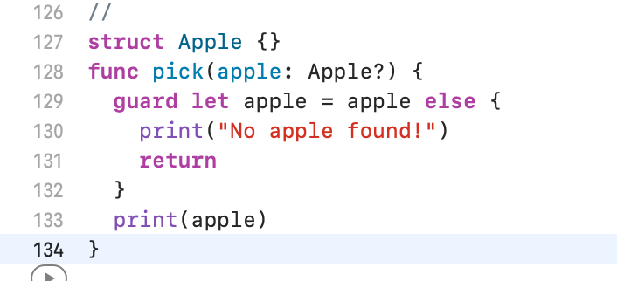

**19.How to inherit multiple protocols in a same class? Give an example?**

Swift supports only multiple inheritance of protocols.

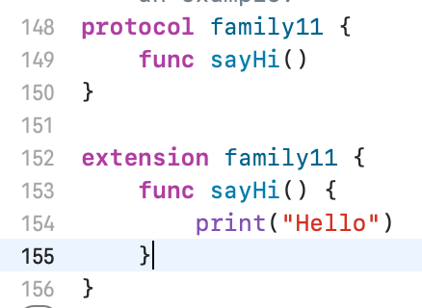

**20.How to append one array to another array in Swift?**

var first = ["John", "Paul"]

let second = ["George", "Ringo"]

first.append(contentsOf: second

print(first)

print(second)

